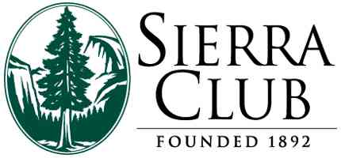
For Immediate Release
For more information: Rick LoBello
915-474-1456
See attached graphic
March 15, 2017
El Paso Sierra Club Meet and Greet
and Premier Showing of Wild Ways, April 8, 2017 at Chamizal National Memorial

The El Paso Sierra Club is invites the community to a Meet and Greet and the Premier El Paso showing of "Wild Ways" on Saturday morning, April 8, 2017 at Chamizal National Memorial Auditorium.
Meet other members of the El Paso Sierra Club and enjoy the El Paso Premier showing of Wild Ways. The 60 minute film explores how newly established wildlife corridors offer hope to endangered species. Before the film we will present an update on our efforts to protect wildlife corridors in Big Bend National Park and adjacent Mexico. Refreshments: 10-10:30am. Meeting starts in Auditorium at 10:30. For more information call 915-217-4233. Please RSVP by text or email to ricklobello@gmail.com or 915-217-4233

